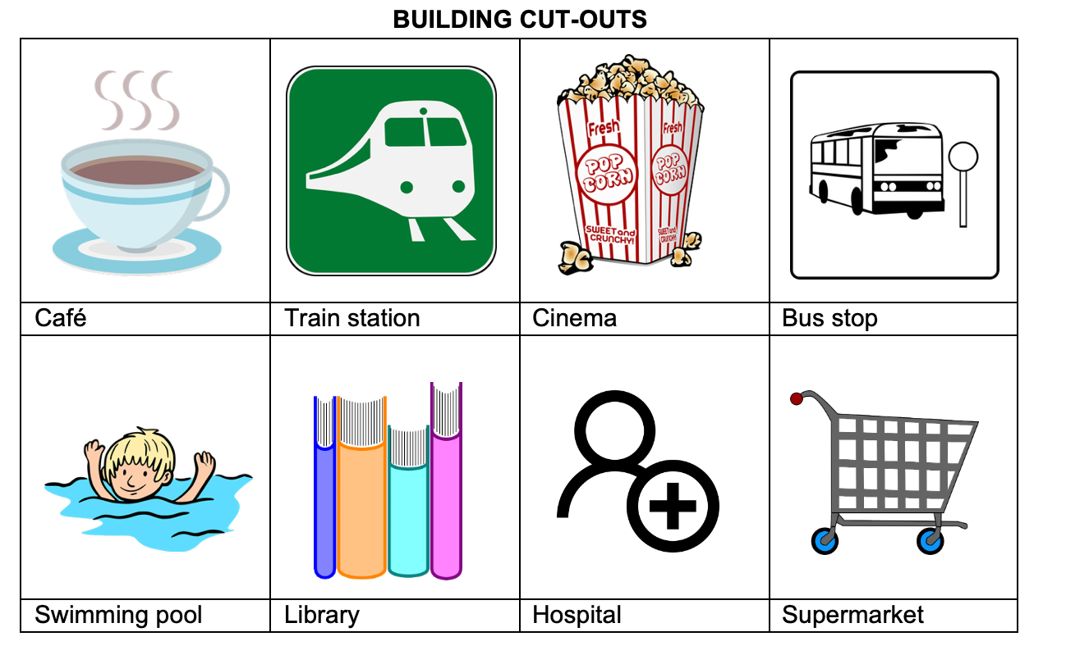
Building cut-outs

Clues A and B
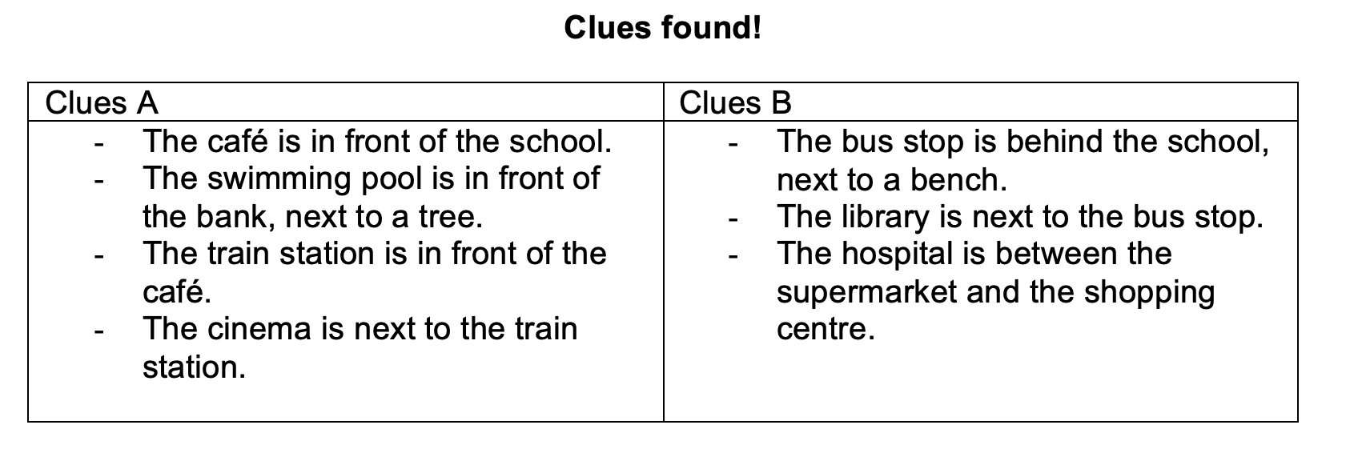

Image Source

All building and place illustrations (school, bank, trees, car, benchmark, café, train station, cinema, bus stop, swimming pool, library, hospital, supermarket) were downloaded from Pixabay.com under the Pixabay Content License. These are royalty‑free, free for commercial use, modifiable, and do not require attribution. The images are incorporated into the activity materials, not distributed as standalone artwork.

