Name:_______________________________

FIND SOMETHING…. | Picture or Word | Measurement
shorter than 10 inches | 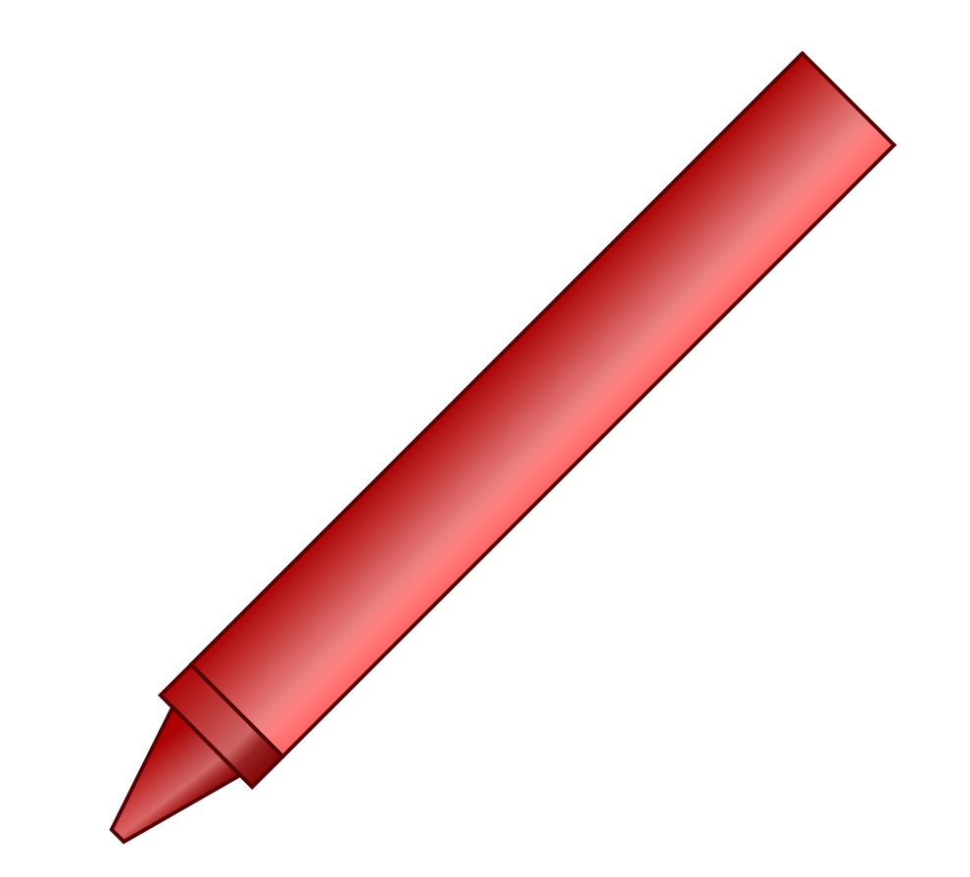  crayon | 3 inches
longer than 12 inches
taller than 20 inches
wider than 15 centimeters

higher than 30 inches
between 5 and 12 inches long

Between 4 and 10 centimeters long

