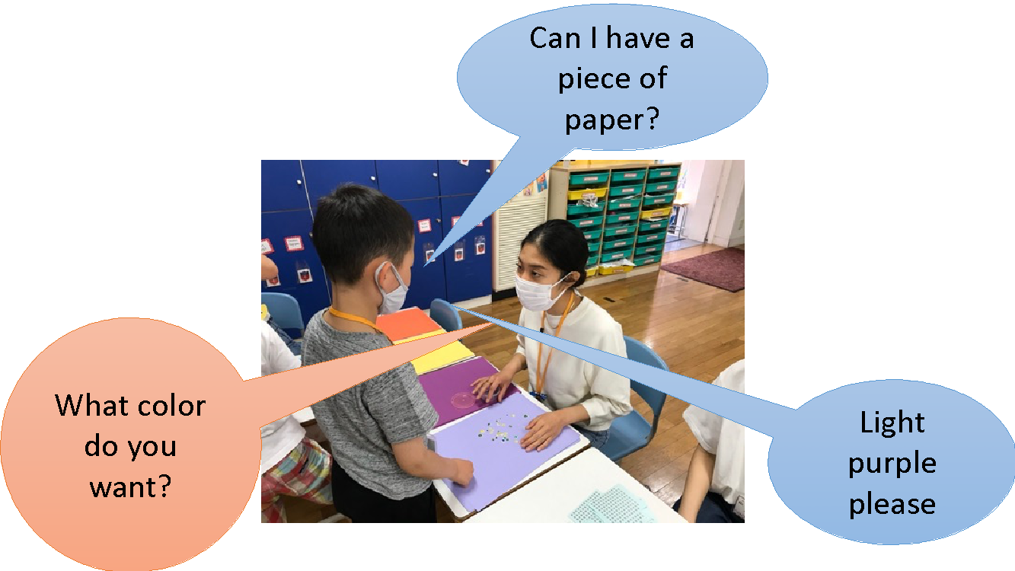
- What you need

  - 1 clear plastic cup
  - 2 pieces of tissue paper
  - A piece of double-sided tape
  - Glitter string

- Listen to the teacher and follow the instructions
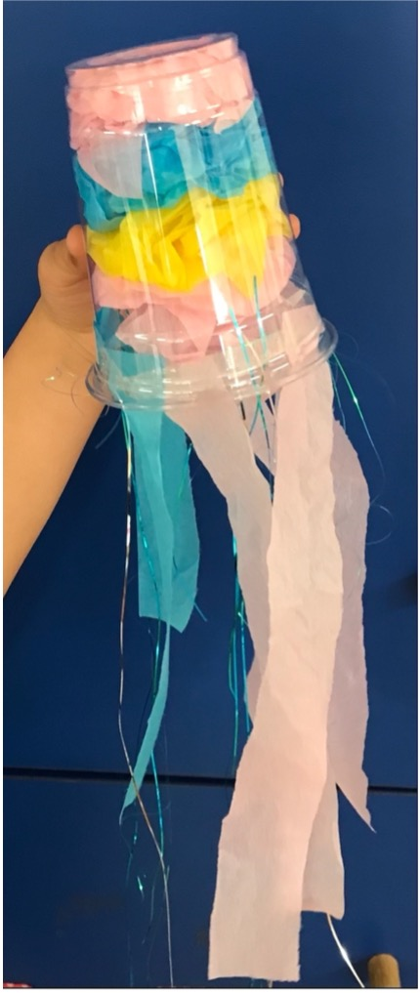

  - Make one piece of tissue paper into a ball and put it inside the plastic cup.
  - Stick the double-sided tape around the rim of the cup.
  - Rip about 4 wavy strips of tissue paper and stick onto the double-sided tape as oral arms.
  - Stick many small pieces of glitter string onto the double-sided tape as tentacles.
  - Attach a string to the top to hang the jellyfish.

